Week 3: JavaScript and PHP Basics
Frontend Interection and Backend Foundations
Fig 1: JavaScript Form Validation
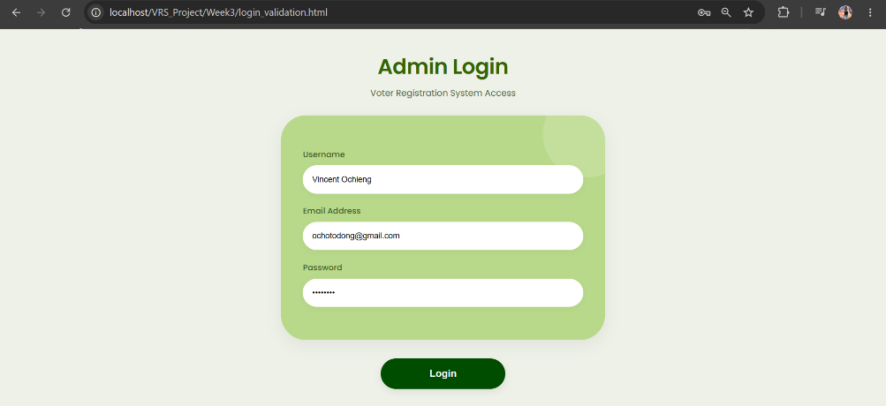
Figure 11: JavaScript Form Validation

Fig 2: Password Strength Checker
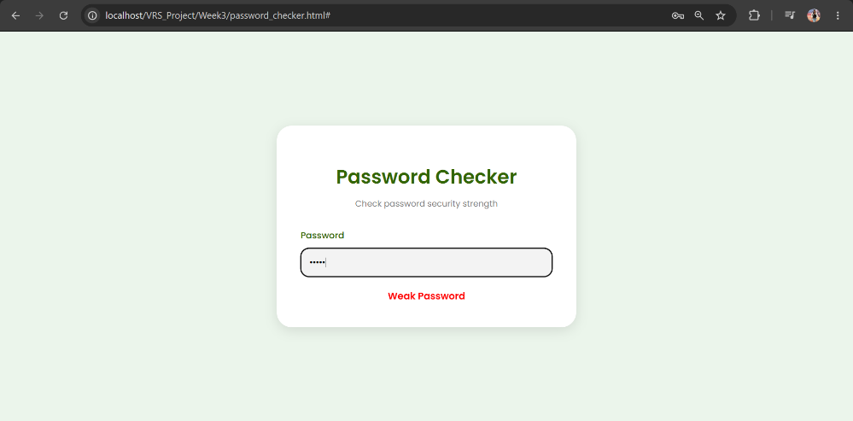
Figure 12: Password Strength Checker
The password I used was 1234 and it was identified as a weak password.

Fig 3: PHP Syntax Practice
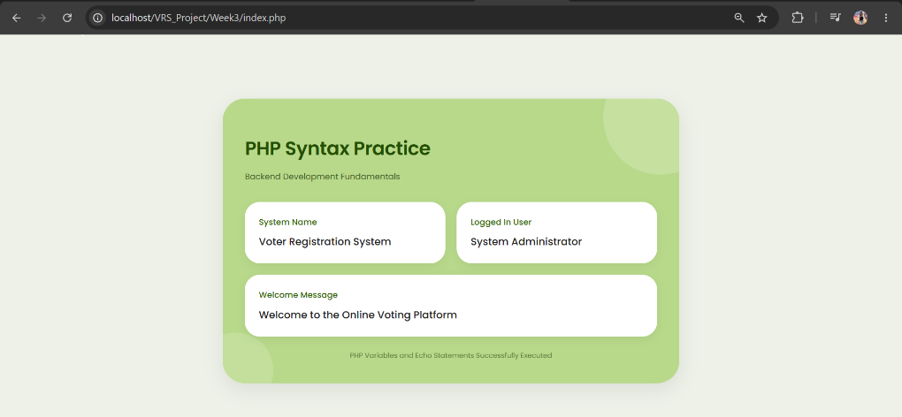
Figure 13: PHP Syntax Practice

Fig 4: Database Connection Script
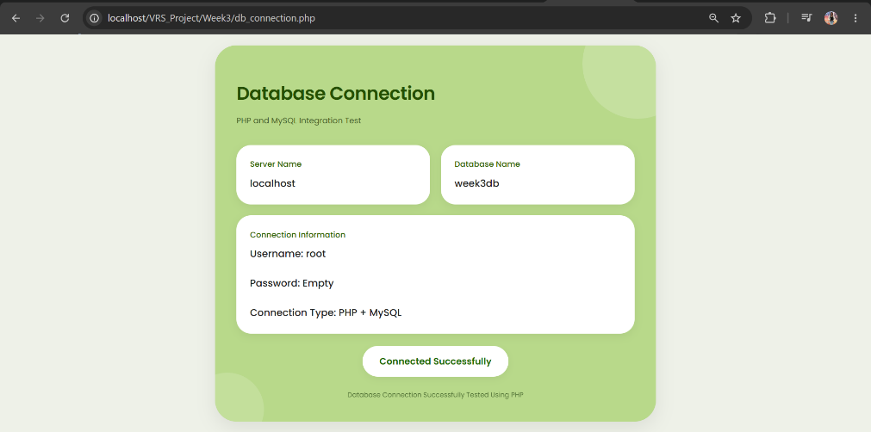
Figure 14: Database Connection Script

Fig 5: Dynamic User Input Handling
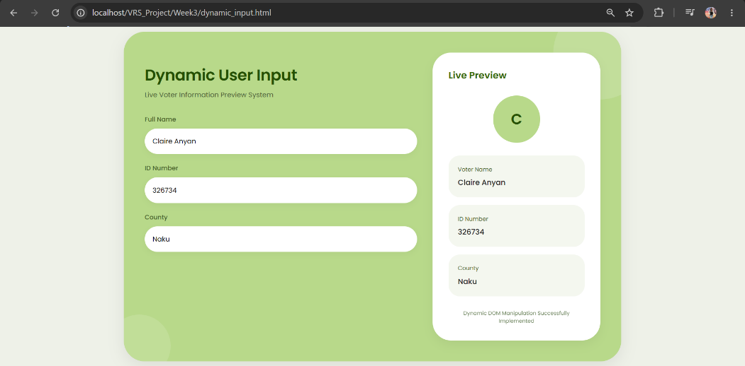
Figure 15: Dynamic User Input Handling

STUDENT REFLECTION
The system used JavaScript for validation and dynamic user interaction. PHP was used for backend scripting and database connection testing. Validation helps prevent empty or incorrect user input. The database connection allows communication between the system and MySQL database. Technologies used include HTML, CSS, JavaScript, PHP, MySQL, XAMPP, and VS Code.

